INSTITUTE OF TECHNICAL EDUCATION AND RESEARCH
(FACULTY OF ENGINEERING)
i
SIKSHA ‘O’ ANUSANDHAN (DEEMED TO BE UNIVERSITY), BHUBANESWAR,
ODISHA

2-BIT COMPARATOR
External Project Report on Digital Logic Design (EET1211)

Submitted by
ARPIT MISHRA | Reg. No.: | 2341013205
OM PRITAM MOHAPATRA | Reg. No.: | 2341013383
AMIT KUMAR NAYAK | Reg. No.: | 2341014126
MADHUMITA NAYAK | Reg. No.: | 2341014131

B. Tech. CSE 3rd Semester (Section – 3AI)

Declaration
We, the undersigned students of B. Tech. of CSIT Department hereby declare that we own the full responsibility for the information, results etc. provided in this PROJECT titled 2-BIT COMPARATOR submitted to Siksha ‘O’ Anusandhan Deemed to be University, Bhubaneswar for the partial fulfillment of the subject Digital Logic Design (EET 1211). We have taken care in all respect to honor the intellectual property right and have acknowledged the contribution of others for using them in academic purpose and further declare that in case of any violation of intellectual property right or copyright we, as the candidate(s), will be fully responsible for the same.

ARPIT MISHRA  Registration No.: 2341013205 | OM PRITAM MOHAPATRA  Registration No.: 3383234101
AMIT KUMAR NAYAK  Registration No.: 2341014126 | MADHUMITA NAYAK  Registration No.: 2341014126

DATE:
PLACE:

Abstract

The project focuses on the design and implementation of a 2-bit comparator, a fundamental digital circuit used in numerous computing and electronic systems to compare two binary numbers. The 2-bit comparator evaluates two 2-bit binary inputs (A and B) and determines their relationship, producing outputs indicating whether A is less than, equal to, or greater than B.
This project encompasses the theoretical analysis of logic gates and combinational circuits, as well as the practical design using truth tables and Boolean algebra to simplify logical expressions. The implementation involves circuit simulation using software tools such as Logisim or Multisim, ensuring accuracy and functionality.
Applications of the 2-bit comparator include digital communication systems, data sorting algorithms, and embedded system operations, where efficient comparison operations are critical. This project aims to enhance understanding of basic digital circuit design and lays the groundwork for creating more complex digital systems. Additionally, it demonstrates the practical significance of combinational logic in real-world applications, fostering a deeper grasp of core concepts in digital electronics.

Contents

Serial  No. | Chapter No. | Title of the Chapter | Page No.
1. | 1 | Introduction | 1
2. | 2 | Problem Statement | 2-3
3. | 3 | Methodology | 4-6
4. | 4 | Implementation | 5-6
5. | 5 | Results and interpretation | 7-8
6. | 6 | Conclusion | 8
7. |  | References | 9
8. |  | Appendices | 10

- Introduction

The 2-bit comparator project involves designing and implementing a digital circuit that compares two 2-bit binary numbers (A and B). The circuit generates three outputs:
A > B (when the first number is greater than the second),
A = B (when both numbers are equal), and
A < B (when the first number is less than the second).
This is achieved using combinational logic, employing basic logic gates such as AND, OR, and NOT. The design process begins with constructing a truth table to represent all possible input combinations and their corresponding outputs. Boolean expressions are derived from the truth table and simplified to optimize the circuit.
The project can be implemented using hardware components or simulated with digital design tools like Logisim or Multisim. It provides practical insights into combinational logic design and helps understand how basic comparison operations are performed in digital systems. The 2-bit comparator finds applications in arithmetic units, microprocessors, and control systems, making it a foundational project in digital electronics.

Problem Statement

I. Explanation of the Problem and Identification of Input and Output Variables
The objective of this project is to design a 2-bit comparator, a digital circuit that compares two 2-bit binary numbers. The circuit determines the relationship between the two numbers and outputs whether one is greater than, equal to, or less than the other. Comparators are essential components in digital systems, used for sorting, decision-making, and control processes in various electronic applications.
Input Variables:
A1 and A0: The two bits of the first binary number, A.
B1 and B0: The two bits of the second binary number, B.
Each input bit can have a value of 0 or 1, resulting in 16 possible input combinations (4 values for A and 4 values for B).
Output Variables:
A > B: High (1) if the binary number A is greater than B.
A = B: High (1) if the binary numbers A and B are equal.
A < B: High (1) if the binary number A is less than B.
The outputs are mutually exclusive, meaning only one output will be high at any given time based on the relationship between A and B.
This identification of inputs and outputs provides the foundation for developing the truth table and the subsequent design of the circuit.
II. Highlighting the Constraints
When designing the 2-bit comparator, several constraints must be considered to ensure the circuit functions correctly and efficiently:
Number of Bits:
The comparator is limited to comparing 2-bit binary numbers. Extending beyond 2 bits would require modifications to the design and additional logic gates.
Logical Exclusivity:
The outputs A > B, A = B, and A < B must be mutually exclusive. Only one of these outputs can be high (1) at any given time, ensuring accurate comparison results.
Hardware Resources:
The circuit should minimize the number of logic gates and connections to optimize for cost, power consumption, and space in hardware implementations.
Latency:
The comparator must operate quickly, ensuring minimal delay in producing outputs. This constraint is critical for applications where real-time comparisons are required.
Noise and Signal Integrity:
In hardware implementations, signal noise and voltage fluctuations should not cause incorrect outputs. Proper design practices, such as using debounce circuits and ensuring clean signal paths, are necessary.
Power Consumption:
For physical implementations, the circuit must be designed to consume minimal power, especially in embedded systems or battery-powered applications.
Scalability and Simplicity:
The design should be modular and straightforward to modify or extend to higher-bit comparators if needed in the future.
By addressing these constraints, the project ensures a robust and efficient design of the 2-bit comparator.

Methodology

Constructing the Truth Table
The inputs are two 2-bit numbers: A (A1, A0) and B (B1, B0). The outputs are:
A > B: 1 if A is greater than B.
A = B: 1 if A is equal to B.
A < B: 1 if A is less than B.
A1 | A0 | B1 | B0 | A > B | A = B | A < B
0 | 0 | 0 | 0 | 0 | 1 | 0
0 | 0 | 0 | 1 | 0 | 0 | 1
0 | 0 | 1 | 0 | 0 | 0 | 1
0 | 0 | 1 | 1 | 0 | 0 | 1
0 | 1 | 0 | 0 | 1 | 0 | 0
0 | 1 | 0 | 1 | 0 | 1 | 0
0 | 1 | 1 | 0 | 0 | 0 | 1
0 | 1 | 1 | 1 | 0 | 0 | 1
1 | 0 | 0 | 0 | 1 | 0 | 0
1 | 0 | 0 | 1 | 1 | 0 | 0
1 | 0 | 1 | 0 | 0 | 1 | 0
1 | 0 | 1 | 1 | 0 | 0 | 1
1 | 1 | 0 | 0 | 1 | 0 | 0
1 | 1 | 0 | 1 | 1 | 0 | 0
1 | 1 | 1 | 0 | 1 | 0 | 0
1 | 1 | 1 | 1 | 0 | 1 | 0

Deriving Boolean Expressions
For A>B:
From the truth table, A > B is true when:
A1 = 1 and B1 = 0
A1 = B1 and A0 = 1 and B0 = 0
The Boolean expression for A > B:
A > b = (A1 . B1’) + (A1 . B1 . A0 . B0’)
For A = B:
From the truth table, A = B is true when:
- A1 = B1 and A0 = B0
The Boolean Expression for A = B:
A = B = (A1’ . B1’ + A1 . B1).(A0 . B0 + A0 .B0)
For A < B:
From the truth table, A < B is true when:
- A1 = 0 and B1 = 1
- A1 = B1 and A0 = 0 and B0 = 1
The Boolean expression for A < B:
A < B = (A1’ . B1)+(A1 . B1 . A0’ . B0)

II. Finding Out the Different Digital ICs for the Optimized Design
To implement the optimized design of the 2-bit comparator, specific digital ICs can be used. These ICs perform logic operations and simplify the construction of the circuit. Below is a list of commonly used ICs and their roles in the design:
1. Basic Logic Gate ICs
These ICs are used to build the comparator circuit based on the Boolean expressions derived during the design process:
- NOT Gate (Inverter): IC 7404
  - Provides the complement of input signals (e.g.,A1’ ,B1’ )
- AND Gate: IC 7408
  - Implements AND operations required in the Boolean expressions.
- OR Gate: IC 7432
  - Implements OR operations required to combine intermediate terms.
- XNOR Gate: IC 74266
  - The 74266 XNOR gate is used in a 2-bit comparator to compare each bit of two numbers for equality and determine if A=B.
2. Dedicated Comparator IC
For optimized design, a ready-made comparator IC can be used to simplify the circuit:
- IC 7485 (4-bit magnitude comparator):
  - Although designed for 4-bit comparisons, it can be configured for 2-bit inputs by connecting unused inputs to ground or logical 0.
  - Directly provides outputs for A>B, A>B , A>B, A=B, A=B, A=B, and A<B, A<B, A<B.
3. Multiplexers (Optional)
In some cases, multiplexers can be used to simplify complex logic by selecting outputs based on control signals.
- IC 74153 (Dual 4-to-1 multiplexer):
  - Can be used to implement the logic for generating outputs if the design uses a multiplexer-based approach.

4.Implementation
  - Drawing the logic diagram using different logic gates.
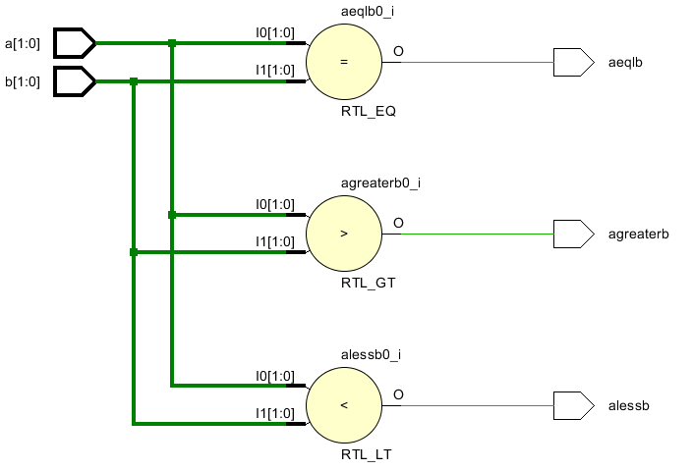
  - Program
1.Code for 2-Bit Comparator

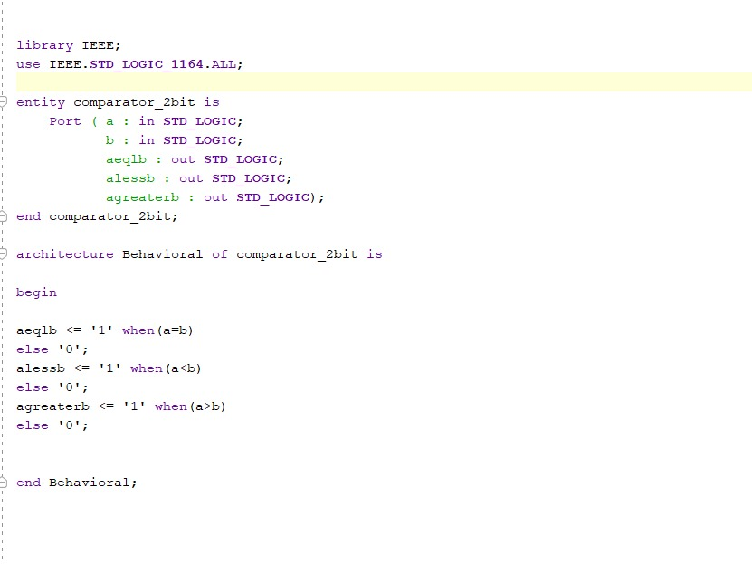

2. TEST BENCH WAVEFORM

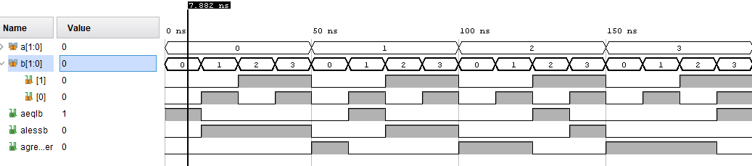
TBW of 2-bit comparator (result showing equality condition: a=0 and b=0)

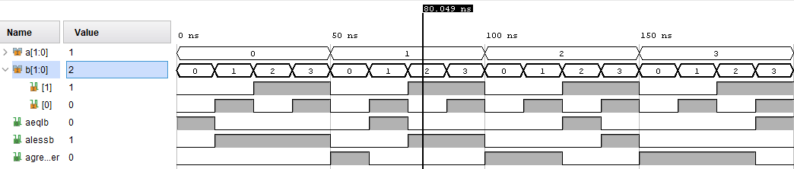
TBW of 2-bit comparator (result showing less than condition: a=1 and b=2)

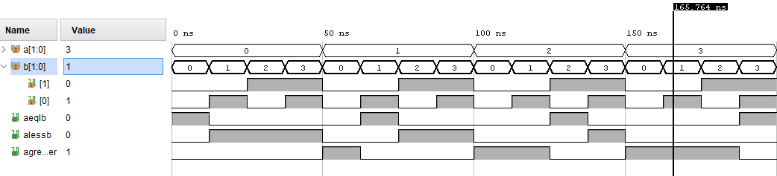
TBW of 2-bit comparator (result showing greater than condition: a=3 and b=1)

Results & Interpretation

Verification of the Output Using a Truth Table
A1 | A0 | B1 | B0 | A > B | A = B | A < B
0 | 0 | 0 | 0 | 0 | 1 | 0
0 | 0 | 0 | 1 | 0 | 0 | 1
0 | 0 | 1 | 0 | 0 | 0 | 1
0 | 0 | 1 | 1 | 0 | 0 | 1
0 | 1 | 0 | 0 | 1 | 0 | 0
0 | 1 | 0 | 1 | 0 | 1 | 0
0 | 1 | 1 | 0 | 0 | 0 | 1
0 | 1 | 1 | 1 | 0 | 0 | 1
1 | 0 | 0 | 0 | 1 | 0 | 0
1 | 0 | 0 | 1 | 1 | 0 | 0
1 | 0 | 1 | 0 | 0 | 1 | 0
1 | 0 | 1 | 1 | 0 | 0 | 1
1 | 1 | 0 | 0 | 1 | 0 | 0
1 | 1 | 0 | 1 | 1 | 0 | 0
1 | 1 | 1 | 0 | 1 | 0 | 0
1 | 1 | 1 | 1 | 0 | 1 | 0

Interpretation of the Renamed Columns:
A=BA = BA=B: The output is 1 when AAA is equal to BBB. This means that A1=B1A_1 = B_1A1​=B1​ and A0=B0A_0 = B_0A0​=B0​.
A>BA > BA>B: The output is 1 when AAA is greater than BBB. This happens when:
A1>B1A_1 > B_1A1​>B1​, or
If A1=B1A_1 = B_1A1​=B1​, then A0>B0A_0 > B_0A0​>B0​.
A<BA < BA<B: The output is 1 when AAA is less than BBB. This happens when:
A1<B1A_1 < B_1A1​<B1​, or
If A1=B1A_1 = B_1A1​=B1​, then A0<B0A_0 < B_0A0​<B0​.
Example:
Row 1: A=00A = 00A=00, B=00B = 00B=00
A=BA = BA=B: AAA and BBB are equal, so the output is 1.
A>BA > BA>B: AAA is not greater than BBB, so the output is 0.
A<BA < BA<B: AAA is not less than BBB, so the output is 0.
Row 5: A=01A = 01A=01, B=00B = 00B=00
A=BA = BA=B: AAA and BBB are not equal, so the output is 0.
A>BA > BA>B: A1>B1A_1 > B_1A1​>B1​ (1 > 0), so the output is 1.
A<BA < BA<B: AAA is not less than BBB, so the output is 0.
Row 16: A=11A = 11A=11, B=11B = 11B=11
A=BA = BA=B: AAA and BBB are equal, so the output is 1.
A>BA > BA>B: AAA is not greater than BBB, so the output is 0.
A<BA < BA<B: AAA is not less than BBB, so the output is 0.
This truth table verifies the comparison logic for all possible combinations of 2-bit binary numbers.

Conclusion

The design and implementation of the 2-bit comparator successfully fulfill the objectives of comparing two 2-bit binary numbers and determining their relationship. Through the construction of a truth table, derivation of Boolean expressions, and simplification using Karnaugh maps or Boolean algebra, an efficient circuit was developed. The use of logic gate ICs or dedicated comparator ICs like the 7485 further optimizes the design for practical applications.
Verification of the outputs using all possible input combinations validated the accuracy of the circuit. The mutually exclusive outputs A>BA > B, A=BA = B, and A<BA < B ensure that the comparator functions as required, providing reliable results for any 2-bit input.
This project demonstrates the foundational principles of digital electronics, including truth tables, Boolean logic, and circuit optimization. It highlights the practical applications of comparators in embedded systems, processors, and digital decision-making circuits. Moreover, it serves as a stepping stone for designing more complex systems such as multi-bit comparators and integrated digital modules.
The project reinforces the importance of systematic design, verification, and optimization in digital system development, offering valuable insights into the workings of combinational logic circuits.

References
- https://ieeexplore.ieee.org/document/7322602
- https://www.elprocus.com/digital-comparator-and-magnitude-comparator/

Appendices
Justification of the architecture / digital ICs used for implementation.
1.7404 IC
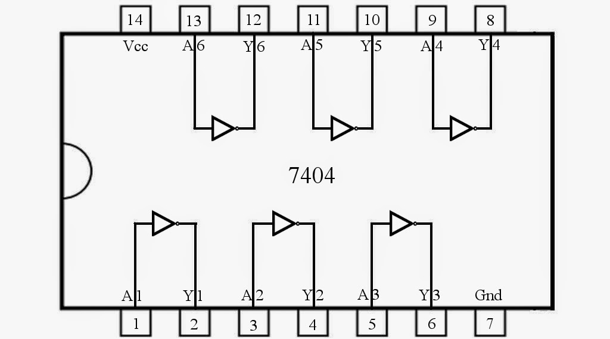
2.7408 IC:
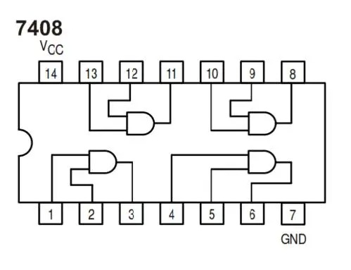
3.7432 IC:
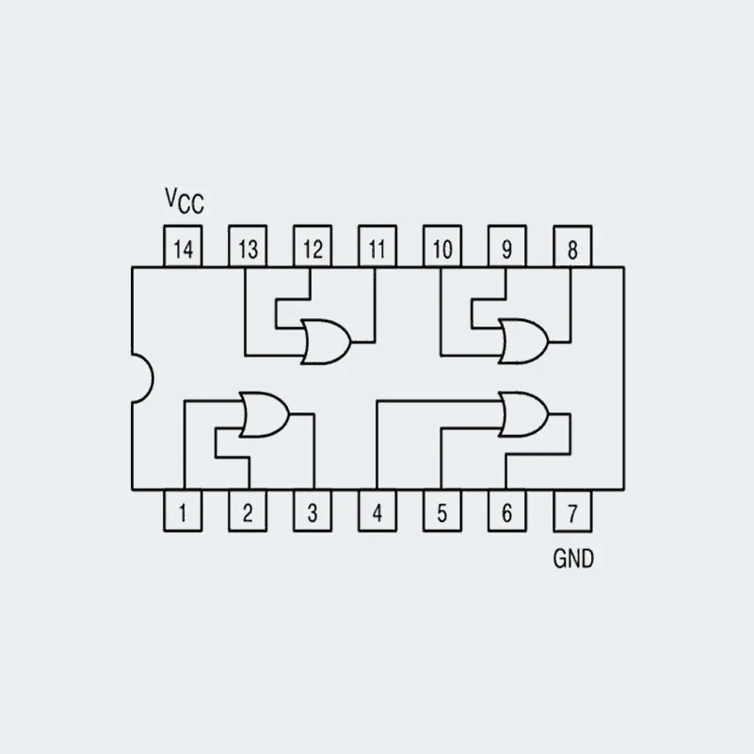
3.74266 IC:
